This homework assignment is based on Chapter 5.

**There are 3 print screens, each worth 33.3%**

**Project #1 (complete the following using functions).**

**#1 Print screen the output with the code below here.**

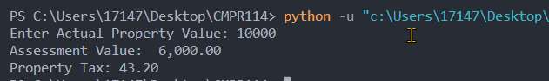

Code:

def calc_property_tax(input):

global assesmentval

assesmentval = input * .6

property_tax = (assesmentval // 100) * .72

return property_tax

def main():

actualval = float(input("Enter Actual Property Value: "))

tax = calc_property_tax(actualval)

print(f"Assessment Value: {assesmentval:,.2f}")

print(f"Property Tax: {tax:,.2f}")

main()

**Project #2 (complete the following using functions).**

**#2 Print screen the output with the code below here.**

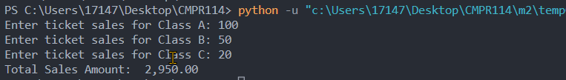

Code:

def calc_totalsales(input1,input2,input3):

totalsales = (input1 * 20) + (input2 * 15) + (input3 * 10)

return totalsales

def main():

salesA = float(input("Enter ticket sales for Class A: "))

salesB = float(input("Enter ticket sales for Class B: "))

salesC = float(input("Enter ticket sales for Class C: "))

totalsales = calc_totalsales(salesA, salesB, salesC)

print(f"Total Sales Amount: {totalsales:,.2f}")

main()

**Project #3 (complete the following using functions).**

**#3 Print screen the output with the code below here.**

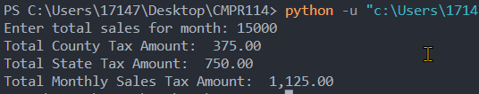

Code:

def calc_statetax(input1):

tax = (input1 * .05)

return tax

def calc_countytax(input1):

tax = (input1 * .025)

return tax

def main():

totalsales = float(input("Enter total sales for month: "))

statetax = calc_statetax(totalsales)

countytax = calc_countytax(totalsales)

totaltax = countytax + statetax

print(f"Total County Tax Amount: {countytax:,.2f}")

print(f"Total State Tax Amount: {statetax:,.2f}")

print(f"Total Monthly Sales Tax Amount: {totaltax:,.2f}")

main()

**Submit this document to Module 2 Homework**